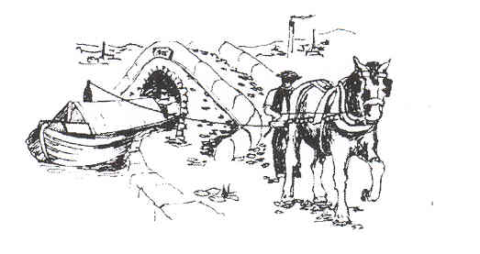
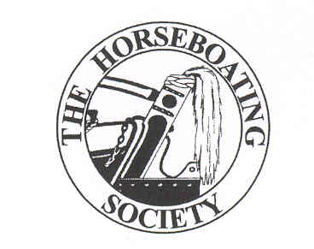
Training and Familiarisation Days in 2008
Preserving and Promoting Horseboating
www.horseboating .org.uk

Name……………………………………………………………………

Address…………………………………………………………………………………………………………………………………………………

Phone numbers……………………………………………………………

Email Address……………………………………………………………

Experience, if any:

Horses……………………………………………………………………..

Motor Boating…………………………………………………………….

Horse Boating……………………………………………………………..

Training/Teaching…………………………………………………………

Please indicate your interest in any particular areas of training:
………………………………………………………………………………………………………………………………………………………….

Will you be prepared to help train others with less experience? Yes/No

Underline dates below when you are available:
Sat Jan 26
Sat Feb 2, Sun Feb 3, Sat Feb 9, Sun Feb 10, Sat Feb 16
Sat March 1, Sat March 8, Sun March 9
(NB HBS AGM March 16- no training), Sat March 22, Sun March 23.
Sat April 5, Sun April 6, (NOT April 12/13), Sat April 19, Sun April 20,
Sat April 26, Sun April 27.

PLEASE RETURN THE FORM TO:
Sue Day, 12 Lower Beestow, Mossley, Ashton-under-Lyne, Lancs. OL5 9QF
or by email to: sueday_horse@yahoo.co.uk

