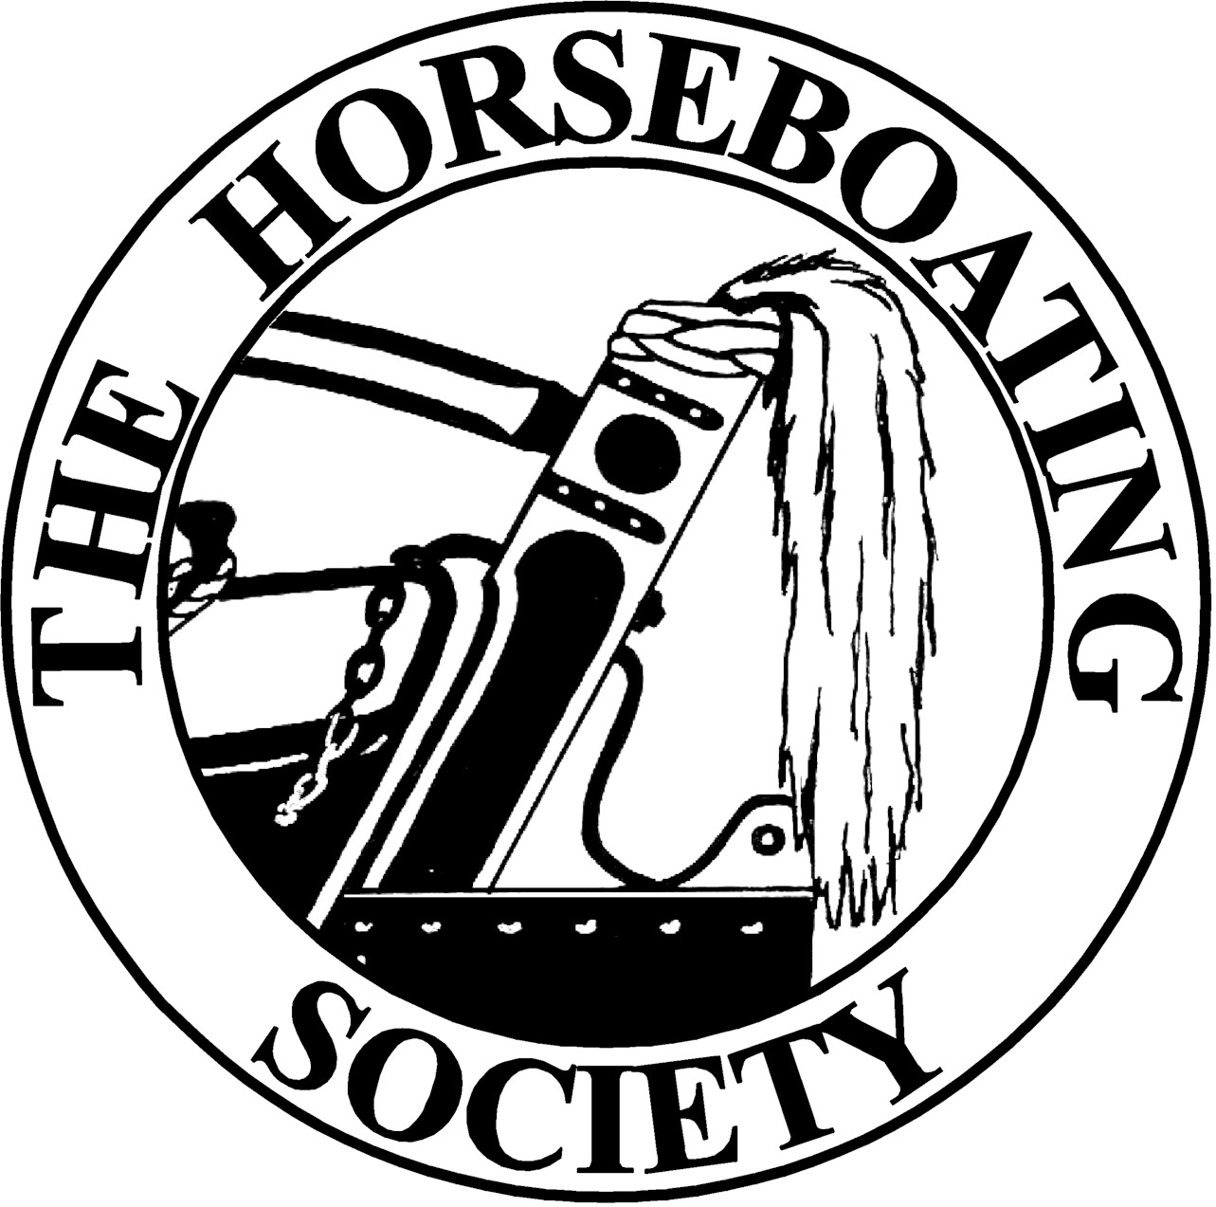
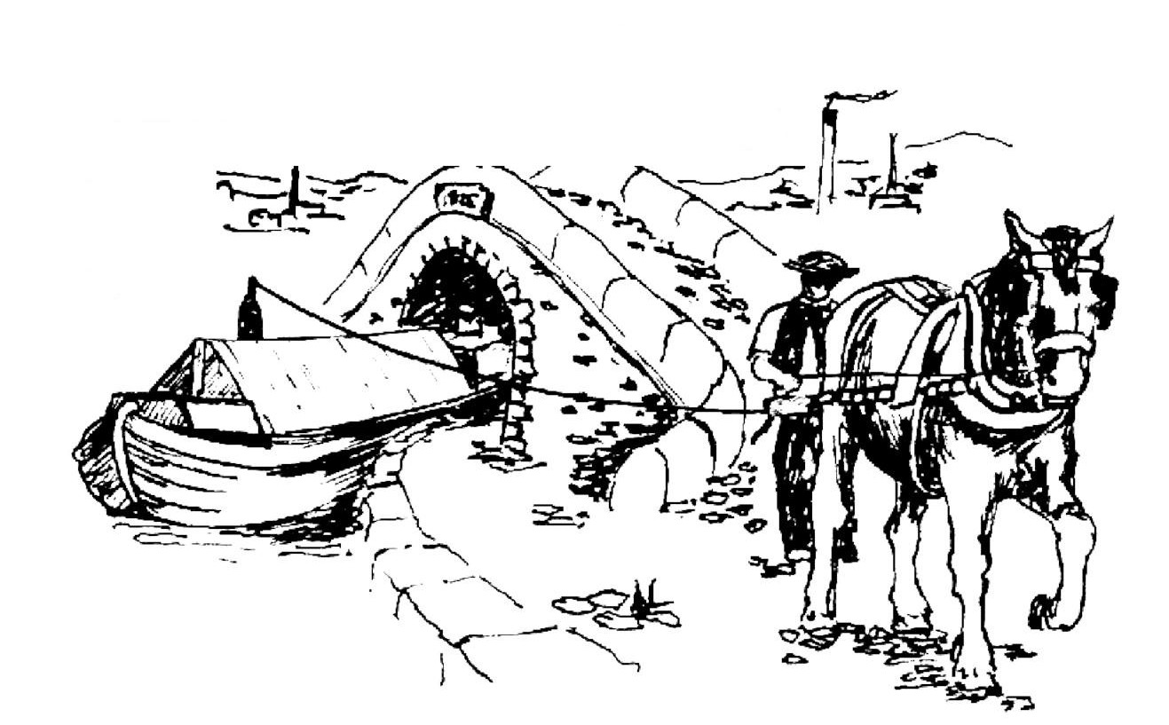
e

Preserving and Promoting Horseboating www.horseboating.org.uk
e
Our Aims and Objectives

1/ Communication and co-operation between persons and organisations with an interest in horseboating.
2/ Training of crew and horses to acquire the skills necessary for horseboating.
3/ Responsible operation of horse-drawn craft on inland waterways.
4/ Maintenance and restoration of the waterway environment to a standard suitable for horse-drawn craft.
5/ Preservation and restoration of the various types of horse-drawn craft.
6/ Education about the history and present use of horse-drawn craft.
7/ Research into the skills, people, horses, boats, structures and equipment involved in horseboating.
8/ Retention of horseboating information in archives.

What's in it for you? How you can help.

Most of all you can join likeminded people who are working to ensure that horse-drawn craft and skills remain a part of the waterway landscape as steam locos are of the railway scene. Members of the Horseboating Society find out about horseboating activities, and can get involved as crew, photographers and video makers, and/or can help with the many varied duties needed to achieve our objectives like campaigning and running the society. Or you can even just be an “armchair supporter” to show your support for the work of the Horseboating Society.

MEMBERSHIP APPLICATION or RENEWAL

Title……. Forename…………..…....…..…… Surname…………...........……………… Date of Birth………….….…

Address………………………………….......................…………………………………………………...........………….….

………………………………………...............................……………………………………..Post Code…………..………

Telephone………………………........………Mobile…………….….........………..Work…………....………...………….

Email address……………………………………………..............………….………....………………………………………..

I can help the society in the following ways…………...........................…………………………………………..

……………………………………………………………………………………………...............................…….……………

……………………………………………………………………………………………..............................…….…………….

PAYMENT Please make cheques payable to The Horseboating Society. Payment by
standing order or bank transfer to Lloyds TSB Account no. 04125081 Sort code 30-94-43

Annual Membership £10 Life membership £100 Donation £ _______ Total £ _________
Payment method: Cheque Bank Transfer Standing Order
Standing Order Form required for future renewals

Signed………………………………………… Date………………………..
Please return to:
The Horseboating Society c/o Barry McGuinness, Membership Secretary,
4 Pole Lane, Failsworth, Manchester, M35 9PB

The Horseboating Society is a company limited by guarantee not having a share capital. Registered in England no. 5436410

